First Assignment

Product Engineer

Instructions:
- Estimated time to complete: 2 hours.
- Please complete all sections. There are no optional questions.
- Please complete this on your own, without AI assistance. We're interested in how you think, not how well you prompt.
- Please submit your completed assignment as a PDF file as well as a copy of your latest resume. Strictly follow this naming convention for both the files:
  - Assignment:
{Last4DigitsOfPhoneNumber} - {YourName} - FirstAssignment - ProductEngineer.pdf
  - Resume:
{Last4DigitsOfPhoneNumber} - {YourName} - Resume - ProductEngineer.pdf
- Please send your submission within the given deadline (mentioned in the covering email). Late submissions will not be accepted.
- The contents of this document are confidential. Please do not share this document in any form with anyone.

1. Candidate Details:
Make sure that the following details are accurate and they match your LinkedIn job application perfectly.

Name:
Phone:
Email:
LinkedIn Profile URL:
Github (or any public Git repositories showing your work) URL:

2. Question: Code Change
Examine the code change shown below. Write a good Git commit message that describes this change.

Bonus: Do you have any concerns about the final version? If so, what would you do differently?

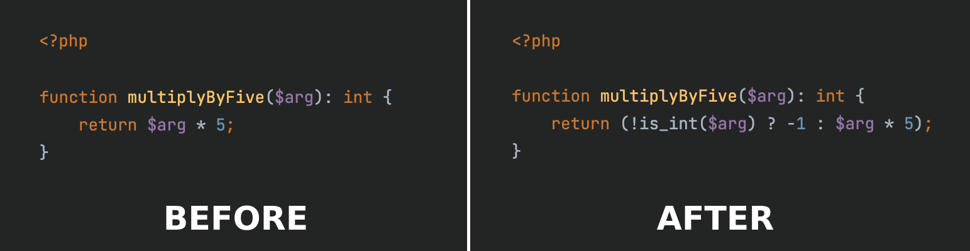

Answer:

3. Question: Task Approach
Imagine this scenario - you are asked to create a "Newsletter Signup" page by your company’s Sales team. You have not received any other inputs from them. What are your first steps to approach this work? Please list them as steps and provide a sequence of tasks if possible.

Answer:

4. Question: Communication For Requirement Gathering
Continuing from the previous scenario - write down your first communication (in email format) with the Sales team for their inputs. Feel free to mention timelines if you think they’ll help the project move forward.

Answer:

5. Exercise: UI/UX Assessment

Instructions:
- On a browser, go to the website - https://shareatdoorstep.com/donate/
- Go through the donation flow. Write down your observations as points in the table below.
- Categorize your points in terms of “Good” vs “Bad”. Try to include at least one point of each type. You can use “Neutral” as a Type as well.
- Feel free to include any feature suggestions as well.
- Don’t spend more than 20 mins on the assessment.
- Be careful of typos and grammar.

# | Summary | Description | Type

6. Exercise: Backend Design

Instructions:
- On a browser, go to the website -
https://milaap.org/crowdfunding/fundraisers
- Observe this page and the fundraisers’ listings.
- Guess the database schema of this page and write it down in the field below.
- Don’t spend more than 30 mins on the assessment.
- Be careful of typos and grammar.

Answer:

That’s all, folks!

